भारतमौसमविज्ञानविभाग |  | India Meteorological Department
Tuesday,03rd June 2025 (13 Jyeshtha 1947 Saka)
Summary of observations recorded at 0830 hoursIST: The Northern Limit of Monsoon continues to pass through 17.0°N/55°E, 17.5°N/60°E, 18°N/65°E, 18.5°N/70°E, Mumbai, Ahilyanagar, Adilabad, Bhawanipatna, Puri, Sandhead Island, 23.5°N/89.5°E, Balurghat, 30°N/85°E. The Western Disturbance as a cyclonic circulation lay over north Pakistan & adjoining Jammu lay over Punjab & neighbourhood between 3.1 & 4.5 km above m. s. l. with a trough aloft in middle tropospheric level with its axis at 5.8 km above m. s. l. ran roughly along Long. 75°E to the north of Lat. 30°N at 0530 hours IST of today. It persisted over the same region. The upper air cyclonic circulation over Haryana & neighbourhood lay over northwest Uttar Pradesh at 1730 hours IST of yesterday. It persisted over the same region at 1.5 km above m. s. l. The north-south trough ran roughly along Long. 92°E to the north of Lat. 22°N at 1.5 km above m. s. l. An upper air cyclonic circulation lay over east Bihar at 0.9 km above m. s. l. An upper air cyclonic circulation lay over Haryana at 0.9 km above m. s. l. The upper air cyclonic circulation over east Bihar & neighbourhood became less marked at 1730 hours IST of yesterday. The trough from east Uttar Pradesh to northeast Assam became less marked.
Day temperatures were markedly above normal (> 5.1°C) at isolated places over Tamil Nadu, Puducherry & Karaikal. appreciably above normal (3.1°C to 5.0°C) at few places over Arunachal Pradesh, Gangetic West Bengal and Odisha; at isolated places over Assam & Meghalaya and Himachal Pradesh. above normal (1.6°C to 3.0°C) at few places over Sub Himalayan West Bengal & Sikkim; at isolated places over Nagaland, Manipur, Mizoram & Tripura, Bihar, east Madhya Pradesh, Saurashtra & Kutch, coastal Andhra Pradesh & Yanam and Telangana. Near normal (-1.5°C to 1.5°C) at many places over Andaman & Nicobar Islands, west Uttar Pradesh and Kerala & Mahe; at most places over east Uttar Pradesh, Konkan & Goa and Lakshadweep; at few places over Uttarakhand, west Rajasthan, Gujarat Region and Rayalaseema; at isolated places over Jharkhand and Punjab. Yesterday, the highest maximum temperature of 44.2°C was reported at Banda (east Uttar Pradesh).
Hailstorm observed at isolated places over Himachal Pradesh, Uttarakhand.
Dust storm observed at isolated places over Rajasthan.
The Southwest Monsoon has been active over Nagaland-Manipur-Mizoram-Tripura and coastal Karnataka. It has been subdued over coastal Andhra Pradesh, Telangana, Rayalaseema, Tamil Nadu and south interior Karnataka.
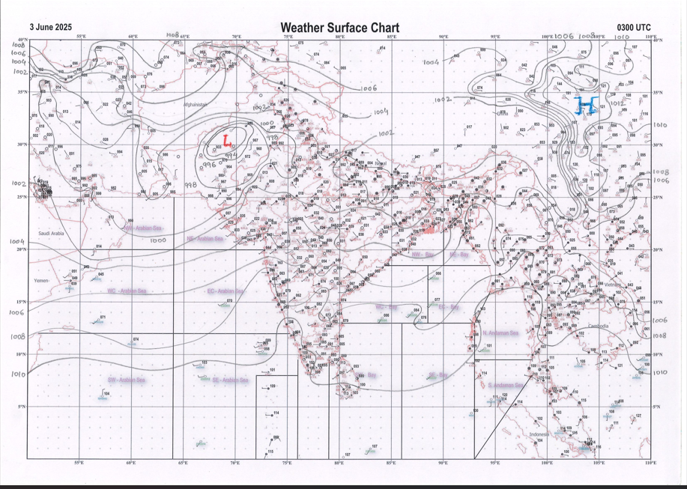 | 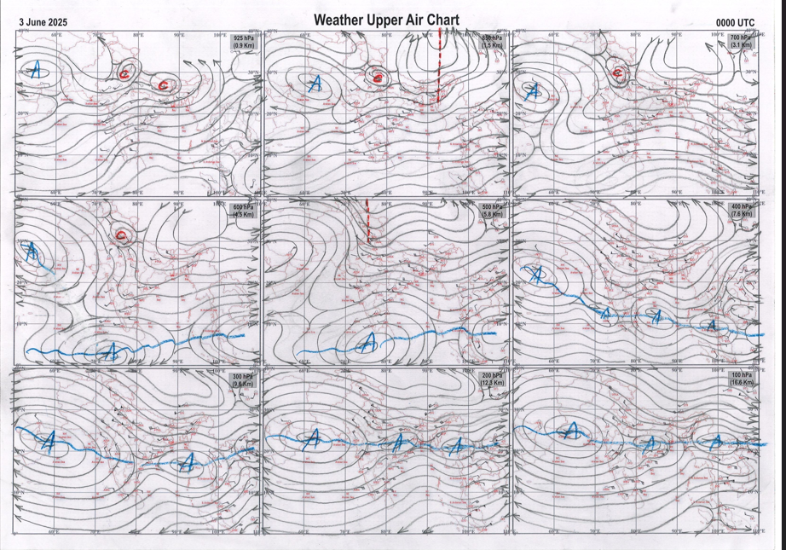
g.1. Analysed surface chart based on 03z observation | Fig.2. Analysed upper air chart based on 00z observation

Dr. S.D.Sanap
Scientist ‘D’
CR & S Office, Pune  Issued at 1245 hrs. IST |  | Weather Forecasting Division  CR&S, Pune

Indian regions | Realised rainfall (chief amount in cm during past 24 hrs):
East | most places: Assam & Meghalaya+ and Nagaland-Manipur-Mizoram-Tripura+  many places: Arunachal Pradesh  a few places: West Bengal & Sikkim  isolated places: Odisha and Jharkhand  dry weather: Bihar  Cherrapunji 11.4, Cherrapunji (rkm) 9.2, Mawsynram 8.2, Lembuchhera & Arundhutinagar 7.2 each, Agartala AP 6.9, Basar 4.9, Tuting 4.6, Mangan 3.8, Singhik 3.5, Tezu & Rajdhanwar 2.5 each, Jangipur 2.2, Tadong 2.0, Rajmahal 1.9, Suri PTO 1.6, Suri (CWC) 1.4, Deogaon 1.0, Saintala 0.3, Na1, Na2 & Na3 NaN each.
North | a few places: Punjab, Himachal Pradesh, Jammu-Kashmir and Ladakh and east Rajasthan+  isolated places: Uttar Pradesh, Uttarakhand, Haryana and west Rajasthan  Jhalarapatan SR & Ramganjmandi SR 8.1 each, Khairagarh 5.6, Chatargarh SR 4.7, Handiaya hmo 4.6, Didwana 4.1, Barnala 3.4, Bharatpur tehsil SR 2.9, Nainital & Ludhiana 2.3 each, Kufri AWS & Churu tehsil SR 1.9 each, Champawat 1.7, Neemsar & Karsog 1.6 each, Dhanaulti 1.4, Ismailabad 1.3, Sundarnagar & Pahalgam 1.2 each, Hardoi & Loharu 1.0 each, Gulmarg RS & Gund 0.9 each, Auraiya (CWC) 0.7, Fursatganj 0.6, Bhiwani 0.5, Jhansi 0.1.
Central | isolated places: Madhya Pradesh, Vidarbha and Chhattisgarh  Kathiwada 3.8, Mandla 3.6, Mehadwani 2.7, Raoti 2.3, Mohgaon 2.2, Sheopur-aws 1.9, Korba 1.2, Balrampur 0.5, Gondia AP 0.3, Deori & Bilaspur 0.2 each, Amraoti 0.1.
Peninsula | most places: coastal Karnataka and Kerala  many places: Konkan & Goa  a few places: south interior Karnataka+  isolated places: Gujarat Region+, Saurashtra & Kutch◆, Madhya Maharashtra, coastal Andhra Pradesh, Telangana, Rayalaseema, Tamil Nadu and north interior Karnataka  dry weather: Marathwada  V.vidyanagar SR 7.2, Petlad 6.8, Anand 6.7, Virajpet 6.5, Dapoli ARG & Muliyar AWS 5.8 each, Bayar AWS 5.7, Puttur HMS 5.3, Sulya 5.0, Mangaluru AP & Kottigehara 4.7 each, Agumbe emo 4.6, Wood braiyar estate 4.1, Canacona 3.9, Harisan malayalam ltd. 3.7, Gaganbawada & Kozhikode 2.0 each, Valparai PTO 1.9, Dabolim n.a.s. navy 1.8, Jadcherla 1.3, Khila ghanpur 1.2, Kavali & Kalaburgi 0.9 each, Kandukur, Rabkavi & Haveri PTO 0.8 each, Mahabaleshwar, Tada & Badvel 0.6 each, Chandgad & Podili 0.5 each, Manavadar & Veraval 0.2 each, Talala & Tirupati AP 0.1 each.
Islands | many places: Lakshadweep  a few places: Andaman & Nicobar  Amini 1.3, Hut bay 1.0, Car Nicobar 0.5, Minicoy 0.4, Agathi 0.2.
Table 2. Forecast / warnings (distribution of rain / thundershowers) for 7 days (valid from time of origin upto 0830 hrs IST of next day)
Sr. No |  | Sub-division Name | Day 1 | Day 2 | Day 3 | Day 4 | Day 5 | Day 6 | Day 7 | Sr. No. | Sub-division Name | Day 1 | Day 2 | Day 3 | Day 4 | Day 5 | Day 6 | Day 7
 |  |  | 03 Jun | 04 Jun | 05 Jun | 06 Jun | 07 Jun | 08 Jun | 09 Jun |  |  | 03 Jun | 04 Jun | 05 Jun | 06 Jun | 07 Jun | 08 Jun | 09 Jun
 | 1 | Andaman Nicobar Islands | W | W | F | S | S | S | S | 19 | west Madhya Pradesh | S  | S  | I  | I  | I  | I | I
 | 2 | Arunachal Pradesh | W +  | F +  | F + | F | F | F | F | 20 | east Madhya Pradesh | S  | S  | I  | I  | I  | I | I
 | 3 | Assam-Meghalaya | W++ | W++ | F +  | F  | F  | F | F | 21 | Gujarat region | S | S | S | I | I | I | I
 | 4 | Nagaland-Manipur-Mizoram-Tripura | W++ | W +  | F +  | S  | S | S | S | 22 | Saurashtra and Kutch | I | I | I | I | I | I | I
 | 5 | Sub Himalayan West Bengal/Sikkim | W+  | W +  | W  | F | F | F | F | 23 | Konkan and Goa | F + | S | I  | I | I | S | S
 | 6 | Gangetic West Bengal | S + | S + | S  | I | I | I | I | 24 | Madhya Maharashtra | I | I  | I  | I  | I  | I | I
 | 7 | Odisha | I + | I + | I + | I + | I | I | I | 25 | Marathwada | I | I  | I  | I  | I  | I | I
 | 8 | Jharkhand | I  | I  | I | I | D | D | I | 26 | Vidarbha | I | I  | I  | I  | I  | I | S
 | 9 | Bihar | I  | S  | I  | D | D | I | I | 27 | Chhattisgarh | I  | I  | I  | I  | I  | I | I
 | 10 | east Uttar Pradesh | S  | I  | I | D | D | D | D | 28 | Coastal Andhra Pradesh and Yanam | I + | I + | I + | I  | I  | I | I
 | 11 | west Uttar Pradesh | S +  | I  | I | D | D | D | D | 29 | Telangana | I  | I  | I | I | I | I | I
 | 12 | Uttarakhand | F +  | S  | I  | I | D | D | D | 30 | Rayalaseema | I  | I  | I  | I  | I  | I | I
 | 13 | Haryana,Chandigarh and Delhi | F +  | I  | I | D | D | D | D | 31 | Tamil Nadu, Puducherry and Karaikal | I + | I + | I  | I | I | I | I
 | 14 | Punjab | F  | I  | I | D | D | D | D | 32 | Coastal Karnataka | W +  | W  | F | F | W | W | W
 | 15 | Himachal Pradesh | F  | F  | S  | I | D | D | D | 33 | North interior Karnataka | I  | I  | I  | S  | S  | S | S
 | 16 | Jammu-Kashmir and Ladakh | F  | S | I | D | D | D | D | 34 | South interior Karnataka | S  | S  | S  | S  | S  | S | S
 | 17 | west Rajasthan | I +  | I  | I  | D | D | D | D | 35 | Kerala and Mahe | W + | W+  | F | S | S | S | S
 | 18 | east Rajasthan | S +  | S  | I  | I  | I | I | D | 36 | Lakshadweep | W  | W  | F | S | S | S | S
Legends: D = DryI = IsolatedS = ScatteredF = Fairly widespreadW = Widespread #= heavy to very heavy rain at a few places with extremely heavy rain at isolated places +++= heavy rain at a few places with very heavy rain at Isolated places ++= heavy to very heavy rainfall @=Isolated exceptionally heavy rainfall + = heavy rain ●/*= rain or snow ♦ = very light rain ≡=fog= thunderstorm with lightning =Squall / Gusty / gale / strong wind ­ =cold wave/cold day += heat wave/warm night/hot and humid weathe r=Duststorm =ground frost = Hail

Fig. 4: Districtwise warnings for five days for Maharashtra State
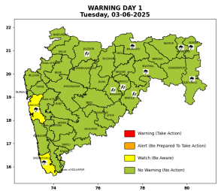 | 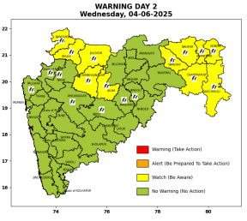 | 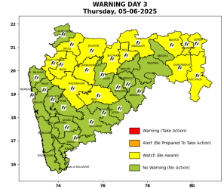 | 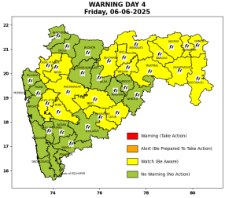 | 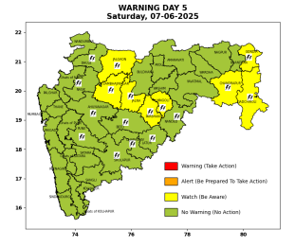

Pune, Lohegaon and Pashan observations at 0830 hrs. IST of Today
 | Temperature (°C) |  |  |  |  | Humidity (%) |  |  |  | Rainfall (mm)
 | Max.  past  24 hrs | Dep.  from  normal | Min.  past  24 hrs. | Dep.  from  normal | Dry  Bulb | At 0830 hrs. IST | Dep.  From  normal | At 1730  hrs. IST of y’day | Dep.  from  normal | Past  24 hrs. | Since  1st June | Dep.  from  normal
PNE | 33.6 | -2.1 | 23.5 | -0.1 | 27.4 | 68 | -1 | 54 | 3 | 0.0 | 1.2 | -9.7
PSN | 31.2 | - | 22.3 | - | 26.2 | 77 | - | 60 | - | 0.0 | 0.2 | -
LHG | 33.6 | -0.4 | 25.3 | 4.3 | 28.9 | 58 | -11 | 45 | -6 | 0.0 | 4.0 | -8.4

 |  |  |  |  |  |  | Local (Pune and neighbourhood) forecast
Max./Min. Temperature (°C) |  |  |  |  |  |  |  |  | Weather
Date | Pune | Pashan | Lohegaon | Chinchwad | Lavale | Magarpatta | NDA | Koregoan Park
03/06/25 | 34/23.5* | 32/22.3* | 34/25.3* | 32/24.7* | 29/22.6* | 33/25.3* | 31/24.3* | 33/25.2* | Mainly clear sky becoming partly cloudy sky towards afternoon/evening.
04/06/25 | 34/24 | 32/23 | 34/25 | 32/25 | 29/23 | 33/25 | 31/24 | 33/25 | Mainly clear sky becoming partly cloudy sky towards afternoon/evening.
05/06/25 | 33/24 | 31/23 | 33/25 | 31/25 | 28/23 | 32/25 | 30/24 | 32/25 | Mainly clear sky becoming partly cloudy sky towards afternoon/evening. Thunderstorm with lightning, light rain likely.
06/06/25 | 33/25 | 31/24 | 33/26 | 31/26 | 28/24 | 32/26 | 30/25 | 32/26 | Mainly clear sky becoming partly cloudy sky towards afternoon/evening. Thunderstorm with lightning, light rain likely.
07/06/25 | 33/25 | 31/24 | 33/26 | 31/26 | 28/24 | 32/26 | 30/25 | 32/26 | Mainly clear sky becoming partly cloudy sky towards afternoon/evening. Thunderstorm with lightning, light rain likely.
08/06/25 | 33/25 | 31/24 | 33/26 | 31/26 | 28/24 | 32/26 | 30/25 | 32/26 | Mainly clear sky becoming partly cloudy sky towards afternoon/evening. Thunderstorm with lightning, light rain likely.
09/06/25 | 33/25 | 31/24 | 33/26 | 31/26 | 28/24 | 32/26 | 30/25 | 32/26 | Mainly clear sky becoming partly cloudy sky towards afternoon/evening. Thunderstorm with lightning, light rain likely.
Rainfall Distribution |  |  | Rainfall Categories | Rainfall (mm) |  | Cloud condition |  |  |  | Rainfall Intensity |  | Range
Widespread (W) | 76-100% |  | Very Light rain | Trace to 2.4 mm |  | Mainly clear sky |  | 1-2 oktas |  | Light Spell |  | 1 cm/hr
 |  |  | Light rain | 2.5 to 15.5 mm |  | Partly cloudy sky |  | 3-4 oktas |  | Moderate Spell |  | 1-2 cm/hr
Fairly Widespread (FW) | 51 – 75% |  | Moderate rain | 15.6 to 64.4 mm |  | Generally cloudy sky |  | 5-7 oktas |  | Intense Spell |  | 2-3 cm/hr
Scattered (S) | 26 – 50% |  | Heavy rain | 64.5 to 115.5 mm |  | Overcast |  | 8 oktas |  | Very Intense Spell |  | 3-5 cm/hr
isolated (I) | 1 – 25% |  | Very heavy rain | 115.6 to 204.4 mm |  |  |  |  |  | Extremely Intense Spell |  | 5-10 cm/hr
D (D) | No Rain |  | Extremely heavy rain | ≥ 204.5 mm |  |  |  |  |  | Cloudburst |  | > 10 cm/hr
Probability Terms in %: |  |  | Heavy snow | 6.5 to 11.5 cms water equivalent of rain
unlikely | < 25 |  | Very heavy snow | 11.6 to 20.4 cms water equivalent of rain
likely | between 25 50
very likely | between 51 75
most likely | >75
* = realized temperature
Mumbai (Colaba) |  |  |  | Nagpur (AP)
Date 2025 | T max °C | T min °C | Weather | T max °C | T min °C | Weather
03/06 | 33 | 27 | Generally cloudy sky with Light Rain or Drizzle. | 38 | 27 | Partly cloudy sky. Thunderstorm accompanied with lightning & gusty winds(40-50kmph).
04/06 | 33 | 27 | Generally cloudy sky with Light Rain or Drizzle. | 38 | 27 | Rain or Thunderstorm accompanied with lightning & gusty winds(40-50kmph).
05/06 | 34 | 26 | Generally cloudy sky with moderate rain. | 38 | 27 | Rain or Thunderstorm accompanied with lightning & gusty winds(40-50kmph).
06/06 | 34 | 26 | Generally cloudy sky with moderate rain. | 38 | 27 | Rain or Thunderstorm accompanied with lightning & gusty winds(40-50kmph).
07/06 | 33 | 26 | Generally cloudy sky with moderate rain. | 38 | 27 | Rain or thundershowers with strong gusty winds.
08/06 | 33 | 26 | Rain. | 39 | 28 | Partly cloudy sky.
09/06 | 33 | 27 | Rain. | 39 | 28 | Partly cloudy sky with possibility of rain or thunderstorm.

